ACCOLADES, ANNOUNCEMENTS AND ADVERTISEMENTS

As a benefit of membership, NH-PCMS is pleased to provide space for announcements and exchanges of these types on its website.

CONGRATULATIONS!
TIMOTHY L. CHASE, MD
Timothy L. Chase, MD of Glen Meade Center for Women’s Health, was recently Board Certified in Female Pelvic Medicine and Reconstructive Surgery (FPMRS), also known as Urogynecology. This is a new sub-specialty certification that is jointly administered by the American Board of Urology and the American Board of Obstetrics and Gynecology. Dr. Chase was in the inaugural class of the new certification that focuses on the diagnosis, management, treatment, prevention and promotion of health for benign female pelvic disorders such as incontinence, pelvic organ prolapse and voiding dysfunctions. He is the first and only physician in Southeastern North Carolina Board Certified in FPMRS.
COASTAL SURGERY SPECIALISTS

Darrell Tackett, MD, Founder

Warren McMurry, MD; David Weatherford, MD; James Harris, MD; Elizabeth Weinberg, MD; Mark Versnick, MD

Coastal Surgery Specialists, located at 1411 Physicians Drive in Wilmington, received a Practice Wellness grant from the North Carolina Medical Society on Thursday May 22, 2014. The grant was awarded to the office for completing a yearlong core employee wellness program. Coastal Surgery Specialists is a general and specialty surgical office with five physicians and two physician assistants. Coastal Surgery has sustained surgical excellence for over twenty-five years in the Wilmington Community and their surgical specialties include bariatric, breast, endovascular, vascular and general surgeries. The practice is also proud to offer an on-site thyroid clinic, ultrasound lab, vein care, wound care, and a fluoroscopy suite.

The Core Practice Wellness program encourages employees of medical offices to live healthier lifestyles by adopting a sustainable health promotion program. This is accomplished by completing a set of criteria developed by the North Carolina Medical Society Employee Benefit Program. The program advocates for physically active, nutritious, and tobacco-free lifestyles. To qualify for the grant, the practice adopted and implemented a 100% tobacco free policy to which the employees abided by, and at least 75% of employees enrolled in the Medical Society plan received their annual preventive care exam. Coastal Surgery viewed this as an opportunity to continually improve the health of their employees and demonstrate this importance to their patients. Coastal Surgery Specialists is extremely proud to announce completion of the program and our acceptance of the Practice Wellness Grant.

OPEN PHYSICIAN POSITIONS

I. Part-Time Physician
Internal Medicine Geriatrics practice seeks part-time physician.
0-1 days per week. Use of EMR and other computerized communications.
Availability to help cover provider vacations would be a plus. Confidential inquiries to Email: ncjob@yahoo.com Placed by Kavita Persaud, MD, Carolina Geriatrics

II. Announcing Available Provider Position

Dawson Street Family Practice, P.A.( 608 Dawson Street, Suite 103), an established practice, is searching for a new provider (MD, PA-C or NP) to see patients on a fulltime basis Monday through Friday, 8a-5p. Position will be available in 2-3 weeks. Please fax resume to Dr. Ron Demas, Medical Director, 910-667-0475. Opportunity available for practice ownership.
Placed by Ron Demas, MD, Dawson Street Family Practice, P.A.

III. Wilmington Veterans Administration Clinic Seeks Physician Providers

Wilmington Health Care Center, Wilmington’s VA Clinic, seeks additional primary care practitioners: Emergency Medicine, Family Medicine and Internal Medicine credentialed physicians. Interested physicians may contact Richard Trotta, MD by phone at 343-5300, EXT. 3555 or by E-mail at Richard.Trotta@VA.Gov. Extensions for Society members at the VA Center are: Bill Holt: 3536; Mike Ward: 3533. One may also go to usajobs.gov to see details of the position.
Placed by Mike Ward, MD, Veterans Administration

IV. Weekend Work Desired

A local physician is interested in working on weekends. Please call (910) 343-5300 Ext 3555 if you have something to offer. Placed by Richard Trotta, MD, Veterans Administration

V. Recent Graduates
University Trained Board Certified or qualified Internist who has an interest in establishing him or herself in a large established practice in Wilmington, NC. Full, part-time or shared. Ultimate plan would be to grow the practice and have this candidate take a leadership position in the practice as I move more toward retirement.
We have 3600 active patients, 3 full time employees and 1 offsite employee. Office is across the street from New Hanover Regional Medical Center. Paperless EMR and billing. I am a BC Internist and Oncologist, practicing Internal Medicine. Training at Northwestern University (AOA) and Duke Internship, Residency and Fellowship.
No hospital call. Practice is fully outpatient ambulatory. Salary negotiable working toward ownership. As mentioned, full, part-time or shared are all possibilities. E-mail if questions: Medicman48@aol.com Posted by James Wortman MD FACP

OFFICE SPACE FOR LEASE OR SALE
Jacksonville, NC Office Space
We are currently seeking a sublease for our Jacksonville, NC office location. Approximately 1600 square feet; fully furnished: two exam rooms, two consult rooms, physician work room, bathroom, dirty utility room, small kitchen and waiting room. The office is available Tuesday, Thursday and Friday all day. Please contact Ashley at 910-332-3660 if interested. Placed by Lydia Wright, MD
DWELLINGS FOR SALE (Scroll Down)
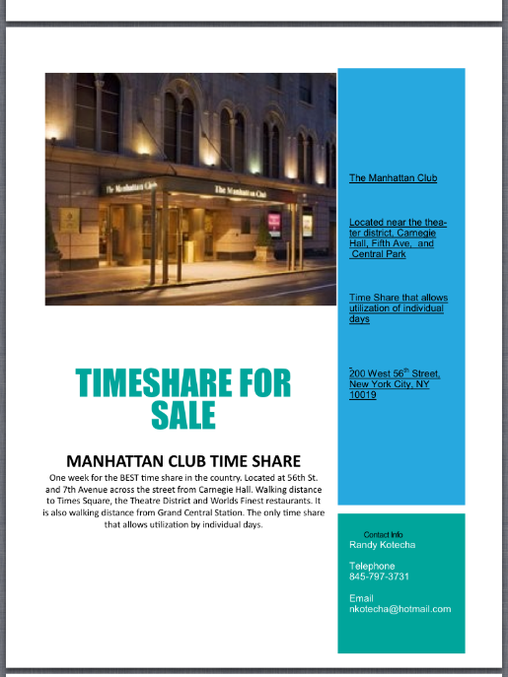
Narendra Kotecha, MD’s Timeshare in NYC across
From Carnegie Hall
Contact: Dr. Randy Kotecha
845-797-3731; nkotcha@hotmail.com
(This image is easily enlarged.)

OTHER ITEMS

